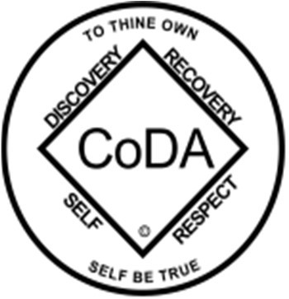

Check one: ￼
CoDA Service Conference (CSC) 2025 Motion Form

Motion submitted by: Board - CoDA Inc.
Motion submitted by: Board - CoDA Resource Publishing (CoRe)
Motion submitted by: (Committee)
Committee Name:

x Motion submitted by: Recognized Voting Entity (VE)
VE Name: NorCal CoDA VE Group Conscience date 7/19/2025 Votes in Favor: 7 Against: _0 Abstentions: 0_
- Motions are to be submitted by the Chair of the VE\Intergroup preferably with a VE\Intergroup email address
- A copy of the minutes on when the Group Conscience was held needs to be submitted with the motion
Submitted Date: 7/22/2025
IMPORTANT DEADLINES:
- Motions are due 75 days prior to CSC which for this year is Wednesday, 2025 July 23.
- Bylaw changes/amendments are due 75 days before CSC which for this year is Wednesday, 2025 July 23 These changes/amendments cannot be brought to the floor if this deadline not met. In accordance with our Fellowship Service Manual (FSM) and CoDA Bylaws, Bylaw amendments are to be submitted to the Board Secretary: secretary@coda.org.
- Revisions are due 60 days prior to CSC which for this year is Thursday, 2025 August 7.

Motion Number: 1. ( ) 2. ( ) 3. ( x ) 4.( ) 5. ( ) (Check One) Revision #: Revision Date:
Note: Please refrain from using CoDA acronyms such as VE, CEC, IMC, etc. when completing this form unless you make a reference such as: CoDA Events Committee (CEC) then use CEC.

Motion Name: Adherence to CoDA Bylaws and Fellowship Service Manual (FSM)

Motion: To add to the CoDA Bylaws Corporation Section, items 8 and 9 below.
- Exception: Only in a **“certain situation”** as described in Service Concept Eleven—namely, when the Board reasonably determines that immediate action is truly necessary to protect CoDA, Inc. from imminent legal or fiscal harm (for example, to fulfill corporate mandatory obligations such as executing binding contracts, approving the annual budget to meet deadlines, filing required nonprofit reports, or maintaining essential insurance coverage)—may it temporarily depart from any conflicting FSM procedure. Such action must be limited strictly to resolving that certain situation and must be reported to and ratified by the next regular Service Conference.

- Nullification: Any Board policy or action that conflicts with the Fellowship Service Manual or Bylaws, except as narrowly allowed under the Exception, shall be considered null and void and have no effect within CoDA World Service.

Intent, background, other pertinent information (Do NOT attach a file. If you have reference documents, please embed them here):
This motion clarifies the role of the Board in relation to conference decisions codified in our Fellowship Service Manual and gives a narrowly scoped exception clause referencing Service Concept Eleven. This provision upholds the primacy of the FSM, honors the Fellowship’s collective will, and clarifies that Board members may only set aside conference decisions to fulfill truly mandatory corporate obligations.

Remarks:

This motion requires changes to the following: (check all that apply)

x_CoDA Bylaws: Page/Section #_ Corporation section 8 and 9
FSM Part 1 – Structure and General Information: Section #
FSM Part 2 – Meeting Handbook: Section #
FSM Part 3 – Guidelines for Other Service Levels: Section #
FSM Part 4 – Service Conference Procedures: Section #
FSM Part 5 – World Level Service Details: Section #
Change of Responsibility:
Other:
Specific details:
Section # and title:
Copy and Paste from most current FSM on coda.org

Motions are to be sent to: submitcsc@coda.org
Bylaw changes/amendments are to be sent to: secretary@coda.org
If you want assistance writing your motion, please send email to Board@CoDA.org
(Data Entry Use Only)

Motion result:

